Team #1 Members: Joshua Collins, Omer Gafar, Louis Hung, Izik Bakhshiyev, Shimu Pan, Pranay Sharma 

Primary Area: HTML, CSS, and JavaScript.

Secondary Area: Pulling data from SQL tables, databases, and APIs.

Overview:

Have you ever wanted to predict how a player performs in a game? Whether it is for a fantasy league or simply watching as your favorite team gains steam to participate in the post-season. Then WinShare is the platform for you. Winshare is an innovative new platform designed for sports enthusiasts and their friends to stay ahead of the competition with a plethora of features. Currently, any NBA fan can track accurate real-time data regarding their favorite teams and players in the NBA as the season unfolds. Winshare provides a unique advantage to our users by providing leading algorithms in data analytics that utilize real-time data. Users have access to all the data from past seasons as well as the current season statistics needed to fuel their interest in the sport.

At the core of WinShare lies a dynamic prediction system for users to take full advantage of to test their sports intuition and knowledge. By providing all sorts of necessary statistics, including player stats, previous game results, and Winshare prediction win rate, users can then make “predictions” on certain outcomes of different games. These predictions are made using points that are free to everyone. These points hold no monetary value but rather serve as a way to rank users against one another. Correct predictions will increase a user's point totals, while an incorrect prediction will lead to a reduction in points. Through making accurate predictions, users would gain more points upon accurate predictions down to points per quarter. Of course, significantly wrong results would lead to a deduction of more points and therefore align high rewards with high risks. WinShare features a leaderboard displaying the top 1,000 users, ranked either by the highest overall score or the highest accuracy rate. We intend to create a competitive environment with Winshare where users can see how they stack up against fellow NBA fans, fostering a sense of community and rivalry as a side dish while enjoying the games.

Users:

James Holden Smith, a 19-year-old Caucasian male from Alaska, is a college student currently participating in a fantasy basketball league with his roommate and friends. Despite his eagerness to join, James lacks extensive knowledge about the NBA, which has put him at a disadvantage in the league. With a high possibility of finishing last and facing a potentially embarrassing punishment, James is eager to improve his understanding of the game. This is where WinShare becomes an invaluable resource for James. WinShare offers a low-stakes environment where he can track and analyze players he might consider drafting. By making predictions on player performance, James can gain the insights necessary to build a competitive fantasy team. With the help of WinShare, James can avoid last place and, more importantly, steer clear of spending 24 hours in a Waffle House as part of the league's punishment.

Geraldine Thompson, a 56-year-old Caucasian female from New York, is married to Timothy Thompson. Tim spends most of his weekend on the couch watching the NBA. Geraldine wants to spend more time with him but doesn’t know much about how professional basketball is played. She hopes using WinShare will give her a better understanding of her husband’s pastime so they can spend more time together. On WinShare, she can look up her husband's favorite team and track their stats over the past 10 years. Now she knows that this year will be the year Tim’s favorite team is most likely to win the national championship. She takes this knowledge and spends her weekends cheering on the team with her husband, making valuable memories.

Stakeholders:

Our Stakeholders will consist of our main sponsor, the NBA, the primary sports league our Web app will be based on. For our points incentive feature, where users will be able to use those points to cash out prizes, our main sponsor will be Fanatics. We’ll also seek sponsorships from tech firms like IBM, AWS, or Google Cloud, who may be interested in promoting their services alongside our analytics features. Furthermore, sports equipment and apparel companies such as Nike, Adidas, and Under Armour could sponsor exclusive promotions or merchandise. Media networks like ESPN and Fox Sports may collaborate for cross-promotion of sports shows and live events. By leveraging these varied sponsors and offering targeted ads and promotions, we’ll create multiple revenue streams while motivating user engagement and activity.

Technology & Technique:

To bring WinShare into the real world, our team would need to work on several parts that would make it a truly compatible and reliable website that would give fellow NBA fans the best experience. Starting from the very base layer, we would use HTML and CSS to form the basic visual layers of WinShare. As for the logic and algorithms of point calculations, we would utilize JavaScript in WinShare. Because each player would need to have their account to track rankings on the leaderboard, we would utilize PHP and MySQL for the backend database that would record down data for each individual. Last but not least, we would like to utilize APIs from different websites such as the official statistics website from the NBA to ensure WinShare’s data is up to date. We would also like to utilize timely visual graphs that will change concerning different teams/players being selected.

Functional and Non-Functional Requirements:

**Functional:**

Provide real-time and historical NBA statistics for players and teams. Prediction system about game outcomes and player performances. A wallet system that stores points unique to each user. Global and friend leaderboard.

**Non Functional:**

Daily login system that rewards users with points. Pull up-to-date statistics on basketball games from the server and games. Dynamic leaderboard updates (once every 30 minutes). Achievements, badges, and streaks for correct predictions.

Expected Timeline:

| 9/6/2024 | 9/10/2024 | Project Proposal (met deadline) |
| --- | --- | --- |
| 9/17/2024 | 9/24/2024 | Scraping Data and API(remaining) |
| 9/24/2024 | 10/8/2024 | Backend(remaining) |
| 10/8/2024 | 10/23/2024 | Frontend and UI(remaining) |
| 10/22/2024 | 10/25/2024 | Midterm Presentation(prepare and practice slides) |
| 11/1/2024 | 11/23/2024 | New updates and finishing touched + Project Presentation (remaining) |
| 12/4/2024 | 12/10/2024 | Team Project Final Packages (remaining) |

Promototional Video Link:

https://youtube.com/shorts/mWwRJyD0O9A?si=YGIouq2I8b_CU7Yt

Site Map:

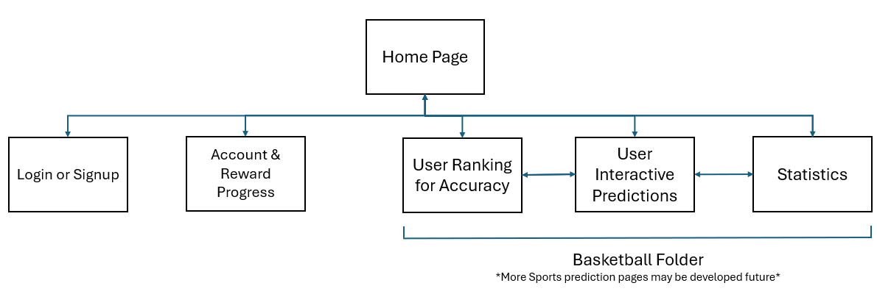

Wire Frames:

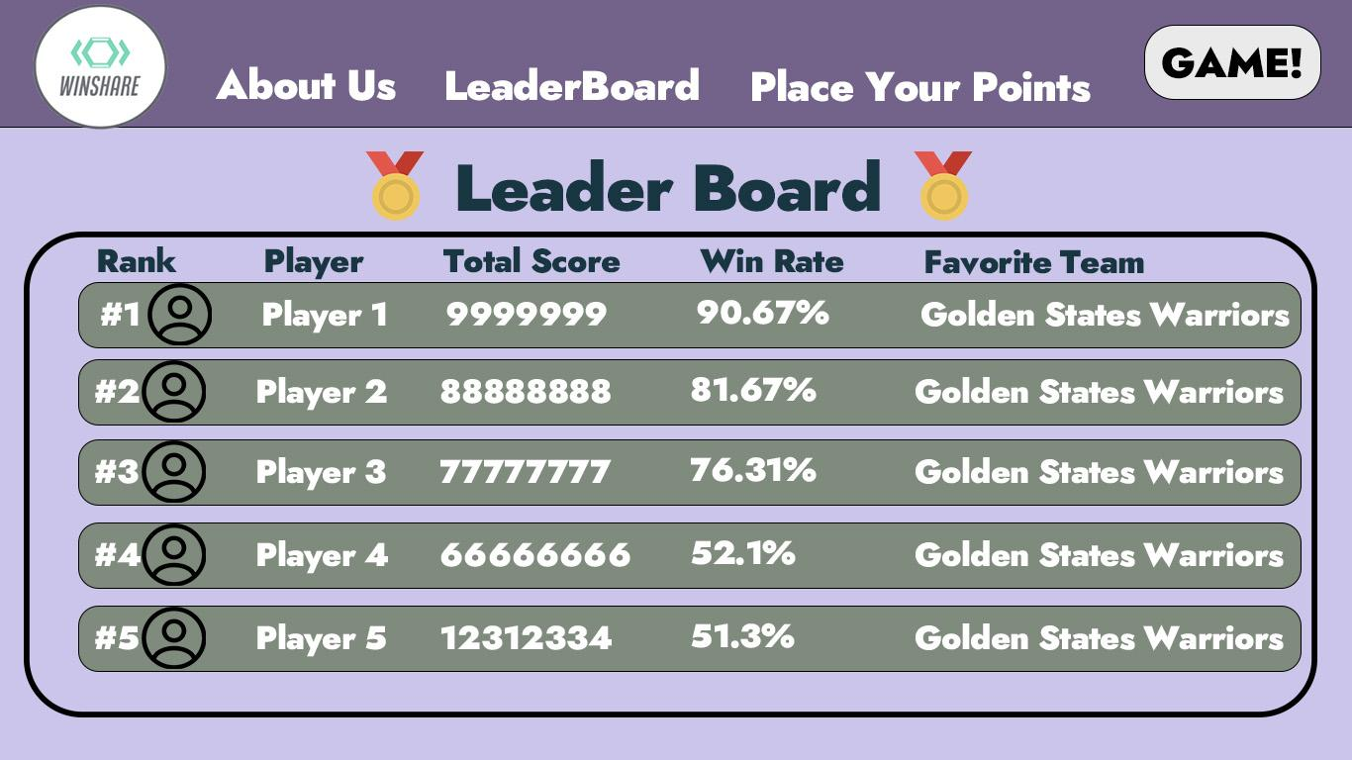

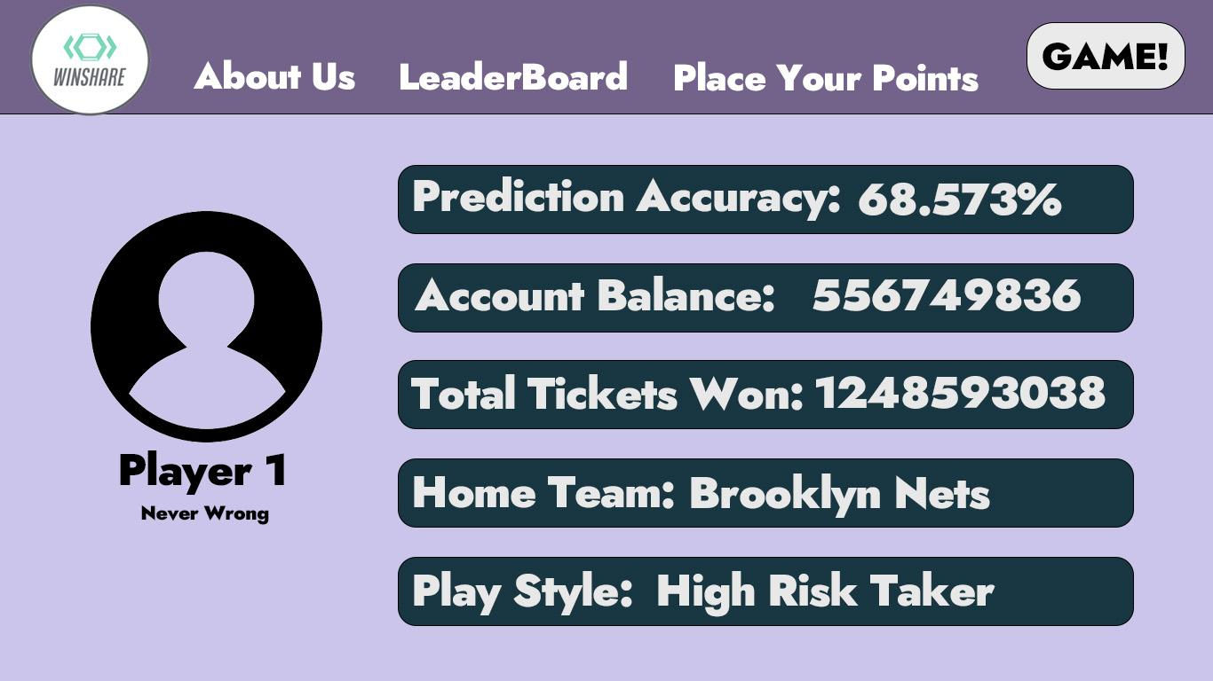

Icon Attribute:

<a href="https://www.flaticon.com/free-icons/medal" title="medal icons">Medal icons created by Pixel Buddha - Flaticon</a>

<a href="https://www.flaticon.com/free-icons/man-avatar" title="man avatar icons">Man avatar icons created by Grand Iconic - Flaticon</a>